

***RISKMASTER***

DA Medical  
Interface System

User Guide

**Proprietary and Confidential**

Delivery Date: 09/30/2018

Last Revised Date: 09/05/2018

**Statement of Confidentiality**

**This documentation contains trade secrets and confidential information which  
are proprietary to DXC Technology. The use, reproduction, distribution or  
disclosure of the documentation, in whole or part, without the express written permission of  
DXC Technology is prohibited.**

**This documentation is also an unpublished work protected under the copyright laws of  
the United States of America and other countries.   
If this documentation becomes published, the following shall apply:**

**Copyright 2000 Computer Sciences Corporation/DXC Technology**

**All Rights Reserved**

***Table of Contents***

1.0 Riskmaster Accelerator 4

**1.0.1 Worker’s Compensation Claim Info Screen** 4

**1.0.2 Policy Insurer Information Screen** 5

**1.0.3 Entity Maintenance** 5

**1.0.4 Self-Insured Detail Screen** 7

**1.0.5 Employee Maintenance** 8

1.1 SUPPLEMENTAL FIELDS 11

**1.1.1 Funds Supplemental Fields** 11

**1.1.2 Claim Supplemental Fields** 15

**1.1.3 Person Involved Supplemental Fields** 17

**1.1.4 Employee Supplemental Fields** 18

**1.1.5 Entity Supplemental Fields** 19

2.0 Medical EDI (Electronic Data Interchange) Screens 21

**2.0.1 Trading Partners Screen** 22

2.0.1.1 Add Trading Partner Information 23

2.0.1.2 Edit Trading Partner Information 24

2.0.1.3 Delete Trading Partner Information 24

2.0.2 EDI Optional Initial Setup 25

2.0.3 Florida Initial Setup 25

2.0.4 Medical EDI Export Process 26

2.0.4.1 Define Criteria Option 27

2.0.4.3 Medical EDI Logs Screen 31

2.0.4.4 Medical EDI Error Log 31

2.0.4.5 Medical EDI Process Log 32

2.0.4.6 Medical EDI Export File Log 32

2.0.5 Medical EDI Import Process 33

3.0 MEDICAL EDI FIELD MAPPING 34

**3.0.1 Export** 34

**3.0.2 Import** 54

# **1.0 Riskmaster Accelerator**

### **1.0.1 Worker’s Compensation Claim Info Screen**

The following fields need to be populated within RISKMASTER to extract claim and policy information.

* Claim Number
* Date and Time of Event
* Date of Claim
* Date Reported
* File Number- will only be populated if an acknowledgement report has been imported into RM. Either the File Number or the EDI Agency Claim Number supplemental field will be used to populate the Agency Claim Number returned in the acknowledgement report from the jurisdiction. If the supplemental field is used, then the File Number will not be populated.
* Policy Name - if organization is insured
* Policy MCO – if organization is insured
* Jurisdiction

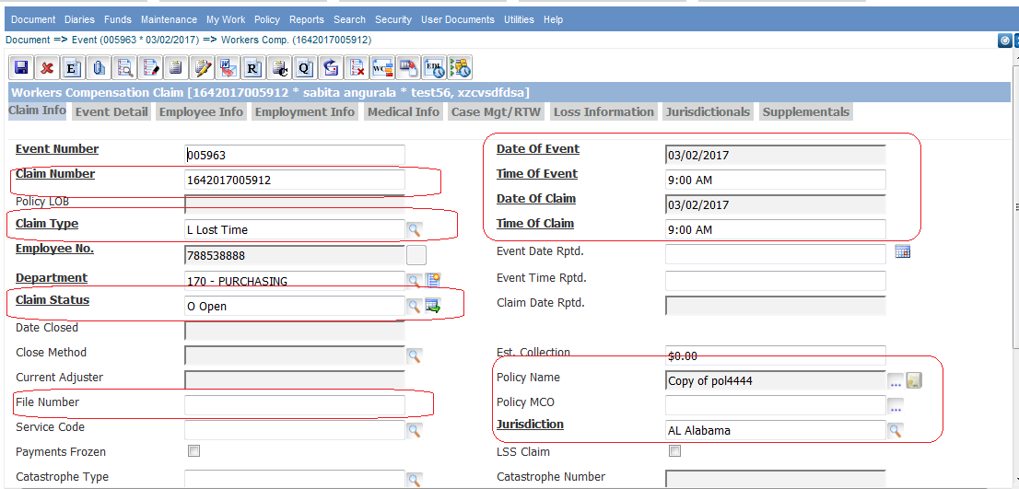

### **1.0.2 Policy Insurer Information Screen**

The following fields need to be populated within RISKMASTER to extract insurer and insured information. This information only needs to be entered if the organization is insured. The insurer must be selected on the attached policy.

* Insurer
* Insured(s)

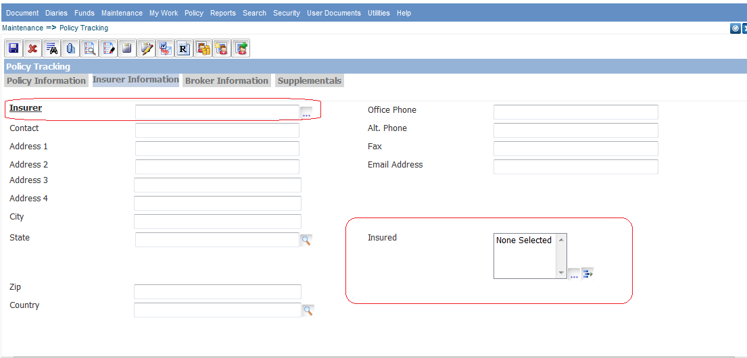

### **1.0.3 Entity Maintenance**

Entity Maintenance tab is used to store information about entities in RISKMASTER. Different type of entities can be selected from RISKMASTER as per claim criterion.

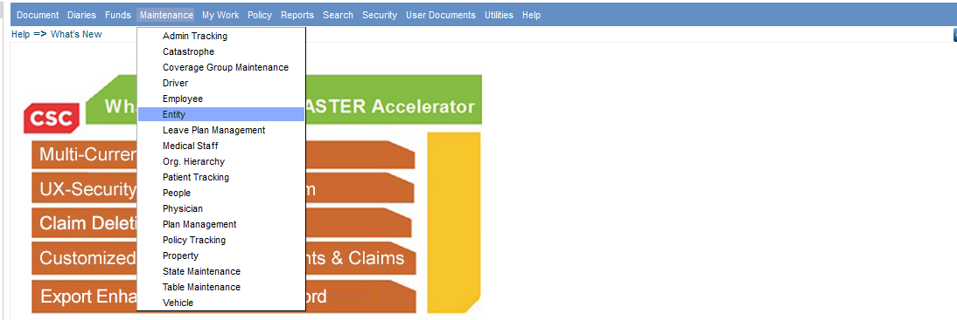

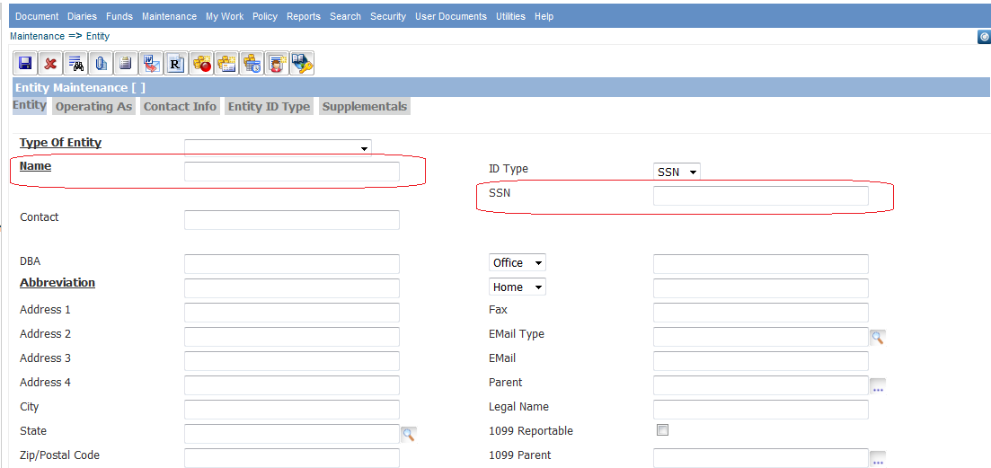

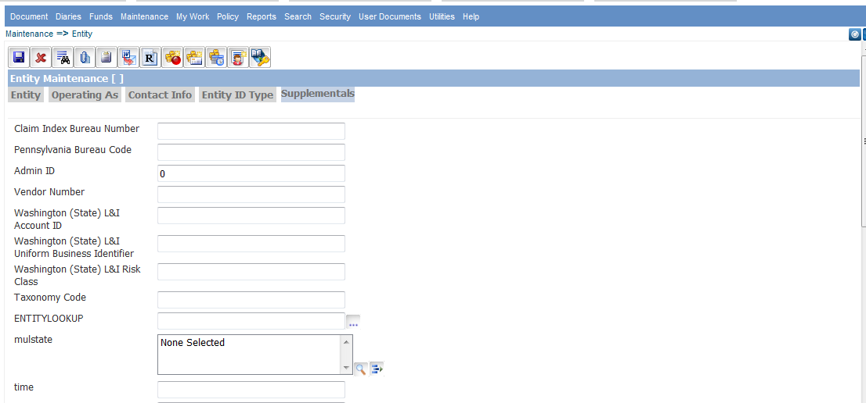  
 **1.0.3.1 Entity Hospital**  
  
Hospital as an entity can be selected from the Entity maintenance screen as shown below.

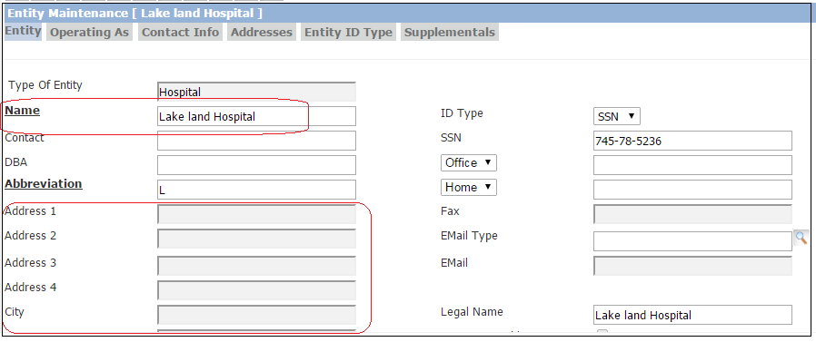

### **1.0.4 Self-Insured Detail Screen**

The Self-Insured Detail screen can be accessed by selecting the “Self-Insured” button on the organizational hierarchy detail screen. This will open the Self-Insured List screen.

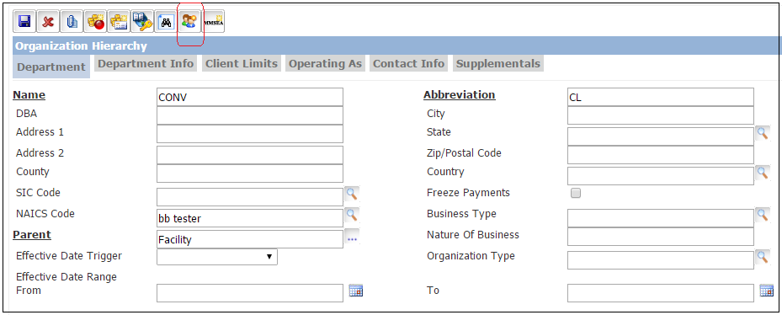

* To add a new Self Insured, select the “Add” button (top right button) on the screen. This will display the Self-Insured Detail screen.
* To edit an existing Self Insured detail, highlight a row on the Self-Insured List screen and select the “Edit” button (middle right button) on the screen. This will display the Self-Insured Detail screen populated with the SI details.
* To delete an existing Self Insured detail, highlight a row on the Self-Insured List screen and select the “Delete” button (bottom right button) on the screen. This will remove the item from the list on the screen and delete the record from the database.

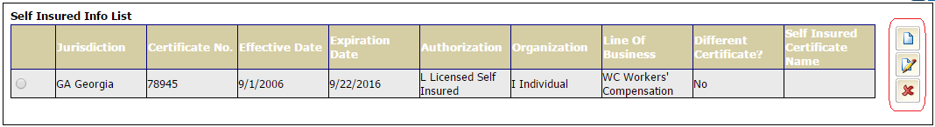

#### 

### **1.0.5 Employee Maintenance**

Employee Maintenance tab is used to store information about employees in RISKMASTER.

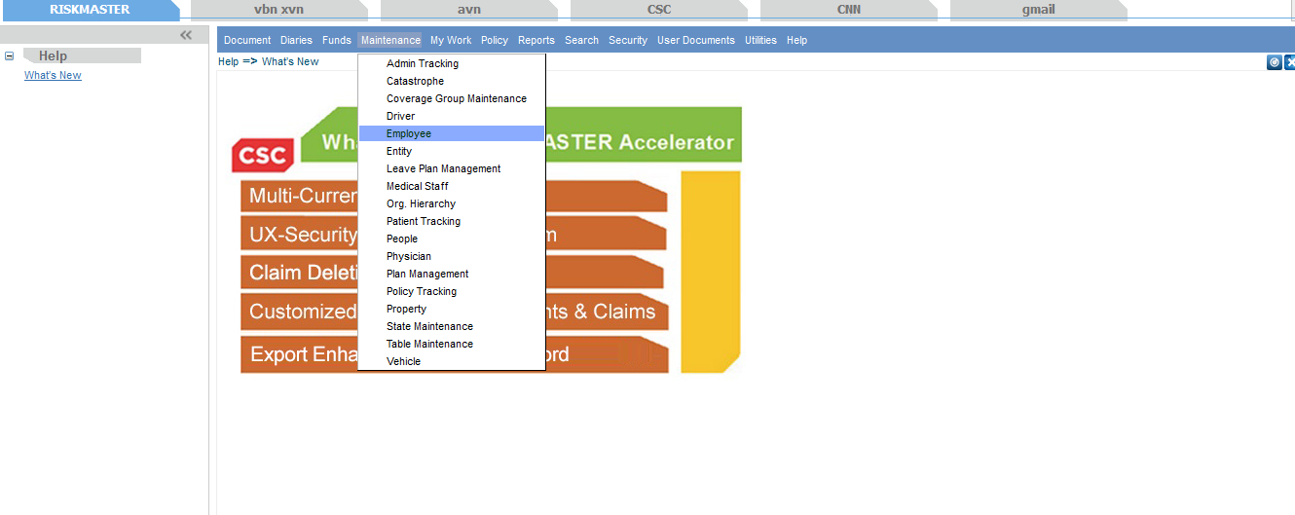

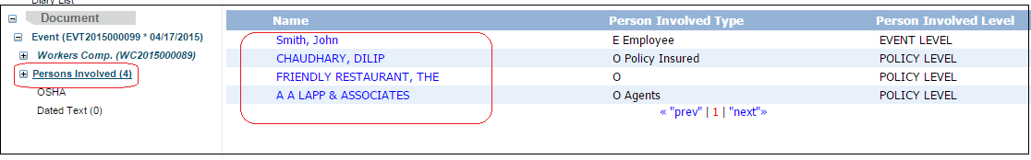

**1.0.5.1 Employee Screen**    
  
The following fields need to be entered within RISKMASTER for entering Employee information on the Employee Maintenance screens.

* Last Name
* First Name
* Middle Name
* Address
* City
* State
* Zip
* Country
* Soc. Sec. No.
* Date of Birth
* Office or Home Phone
* Title
* Sex

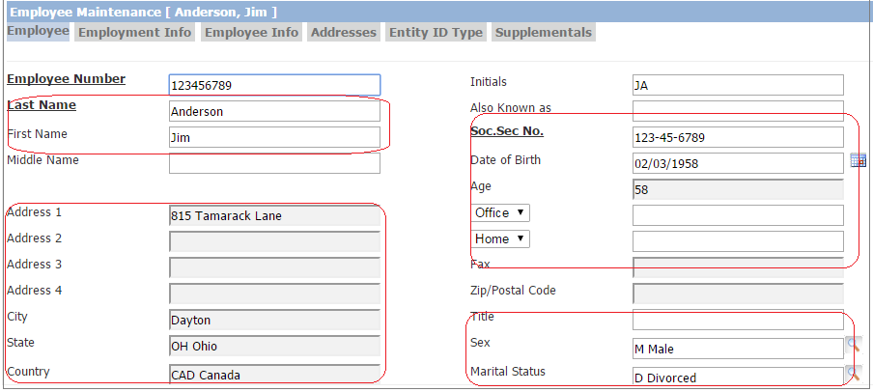  
  
**1.0.5.2 Employment Info Screen**

The following fields need to be entered within RISKMASTER for entering Employee information on the Employee Maintenance screens.

* Date Hired
* Position Code
* Department
* Weekly Rate
* No of Exemptions
* Work Week – these fields are used to calculated DN0064 Number of Days Worked.

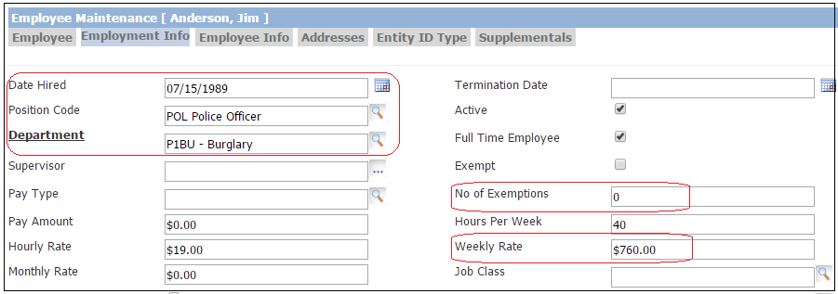

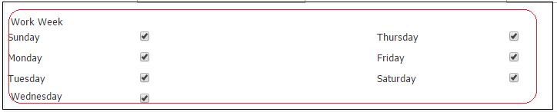

# **1.1 SUPPLEMENTAL FIELDS**

**1.1.1 Funds Supplemental Fields**New Medical Bills / Florida Medical Bills Specific Funds supplemental fields have been added to RISKMASTER as part of the database upgrade. Please refer to following rmA screens to populate data into funds supplemental.  
  
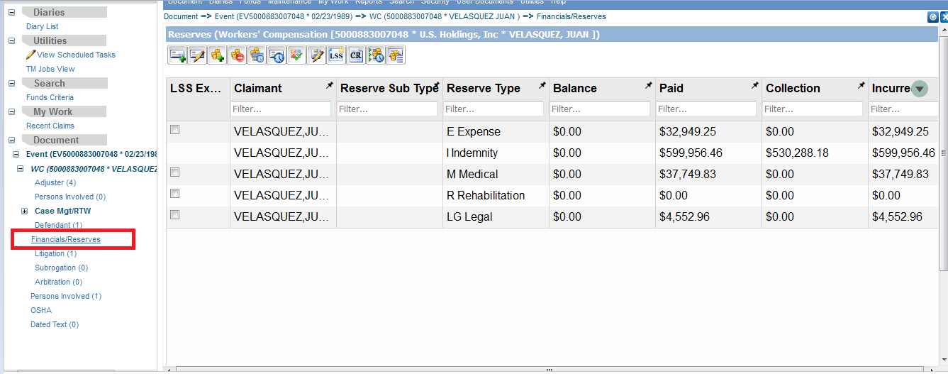

Select “Make a new payment” option to make a new transaction as shown below.  
  
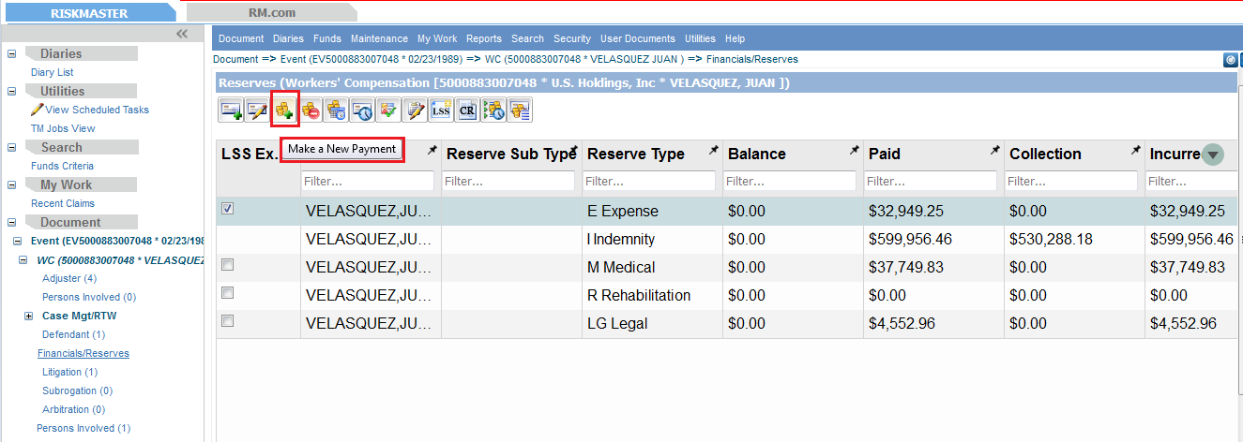  
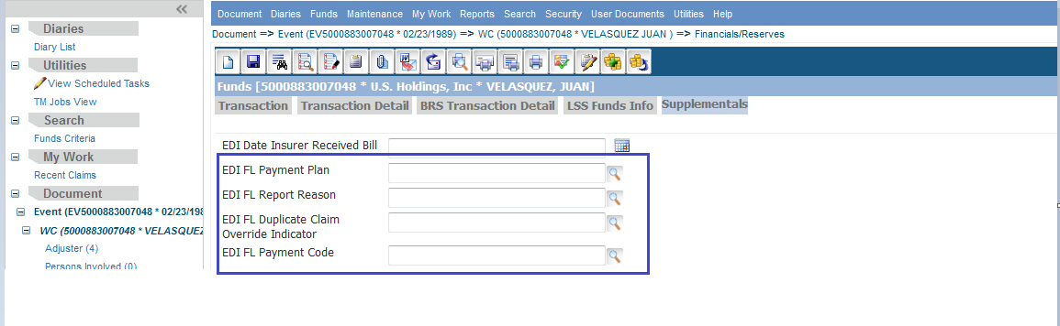

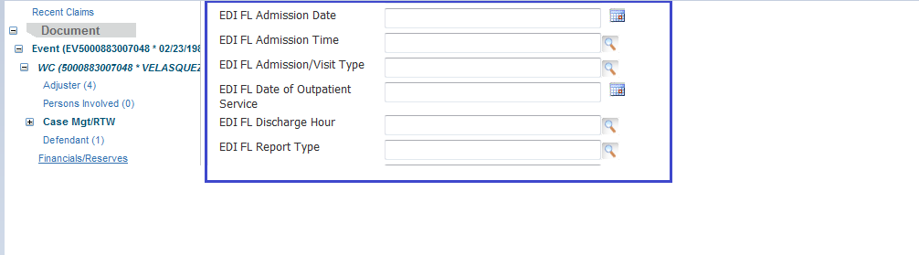

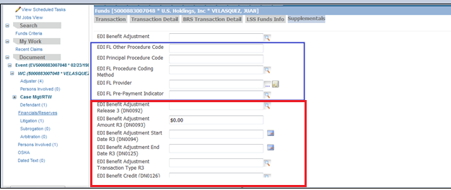  
  
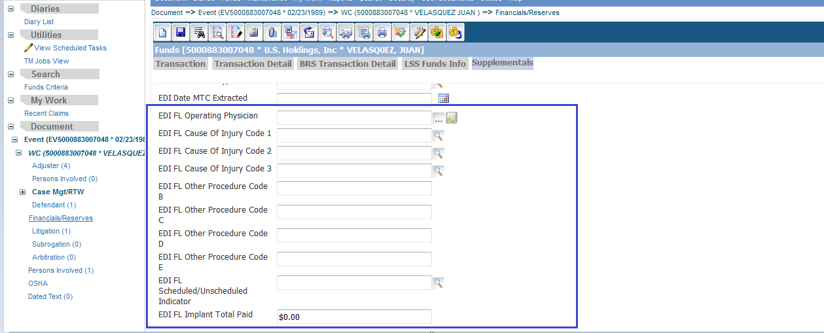  
  
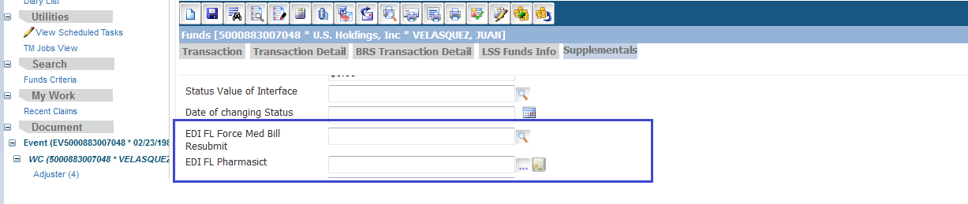  
  
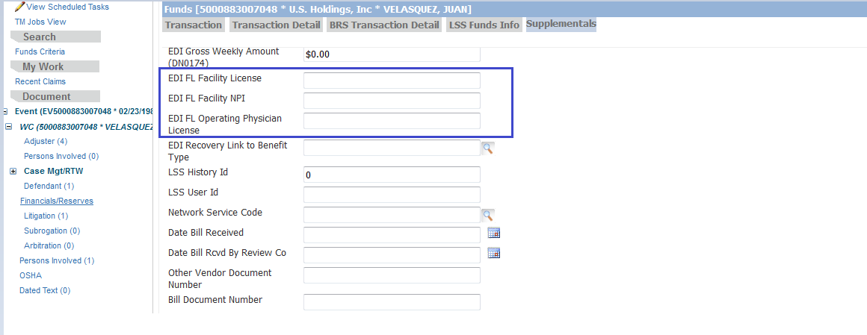  
  
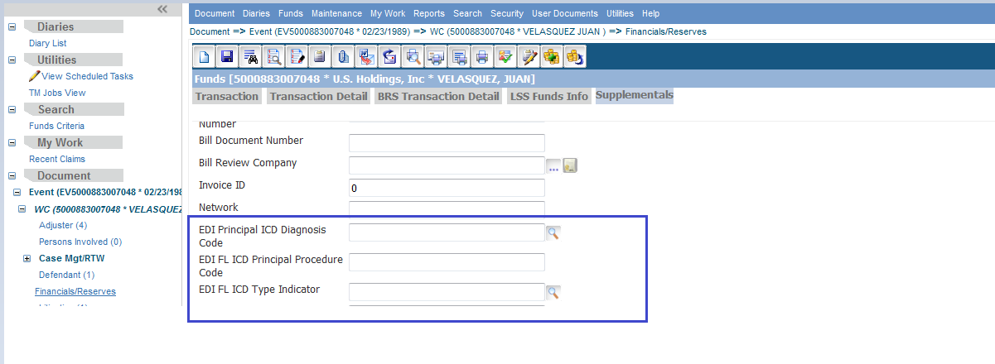  
  
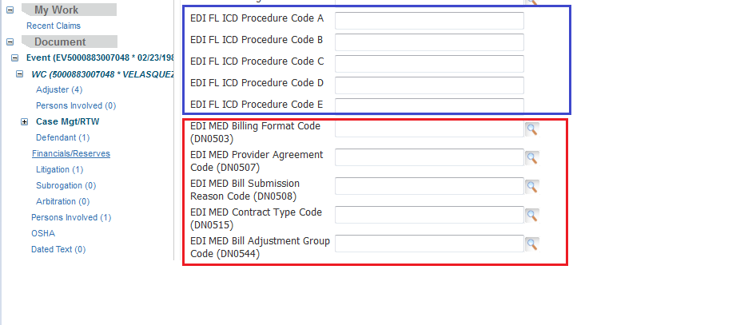  
  
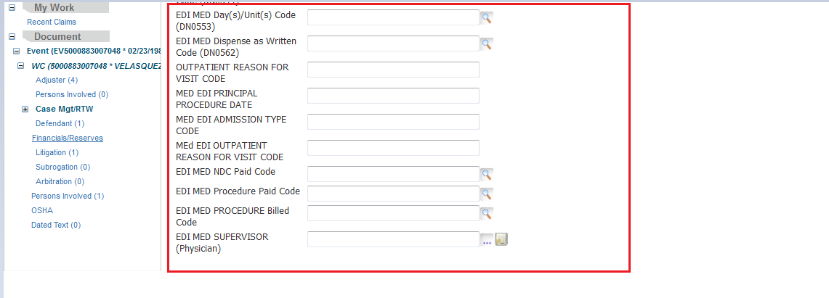  
  
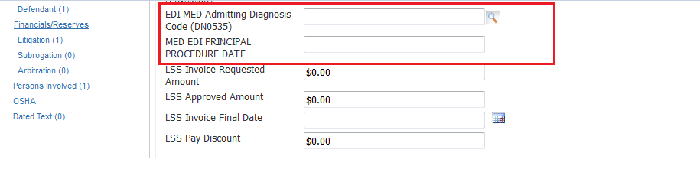

**1.1.2 Claim Supplemental Fields**For populating data into claim supplemental, use the following fields :  
  
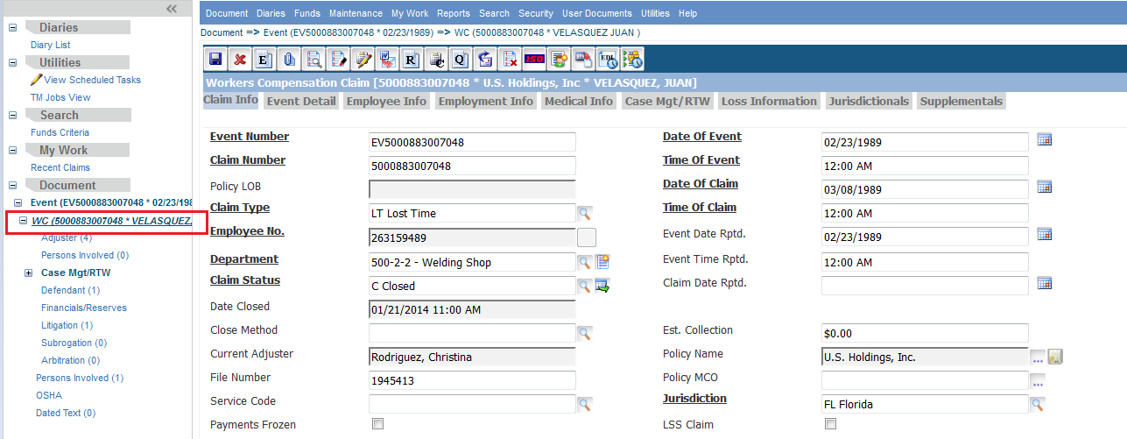

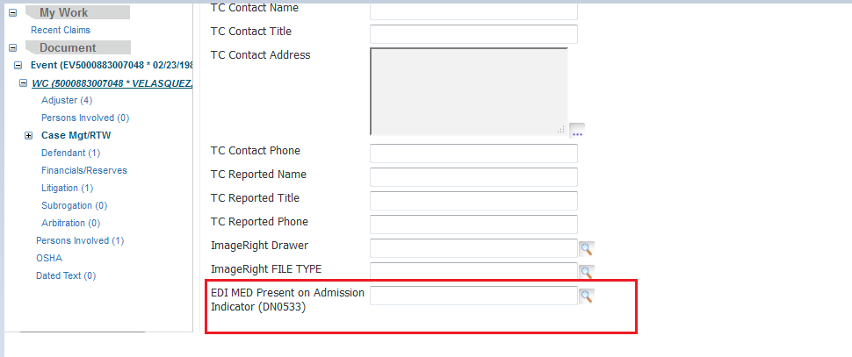

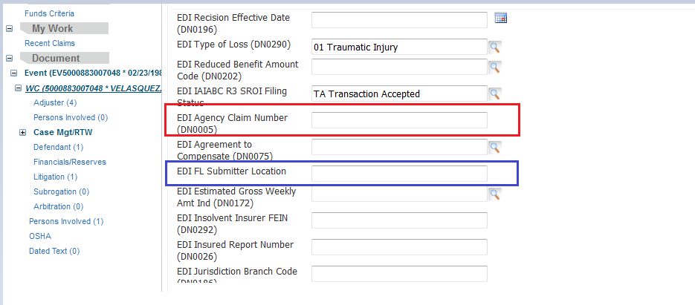

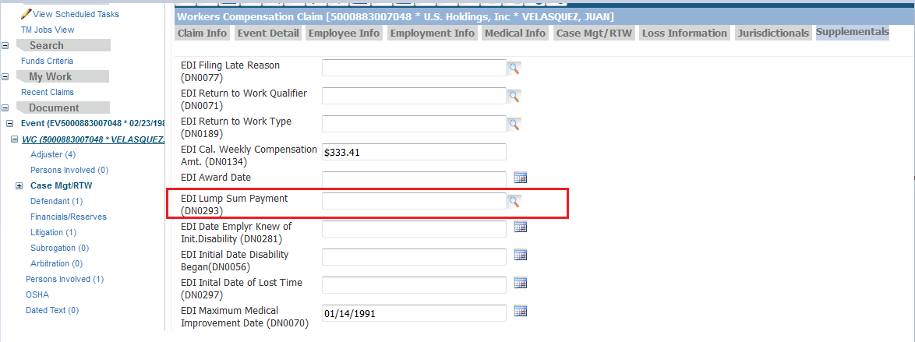  
  
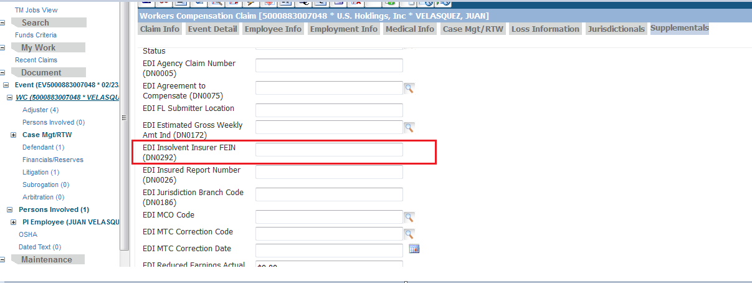

**1.1.3 Person Involved Supplemental Fields**For populating data into person involved supplemental, use the following fields :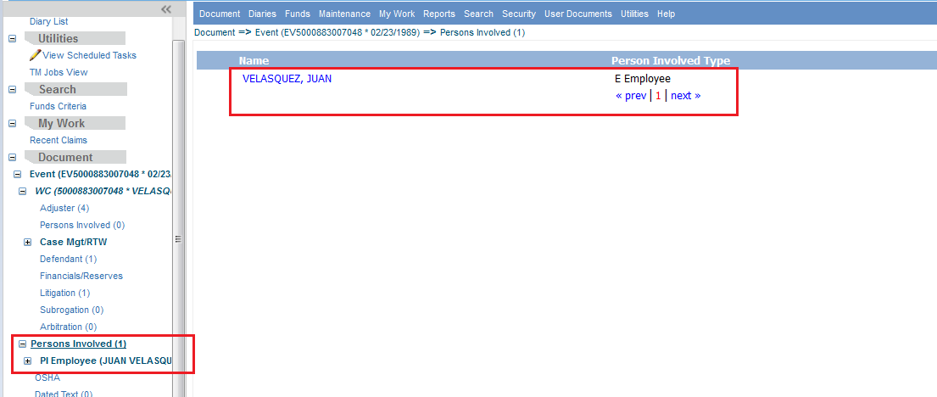  
  
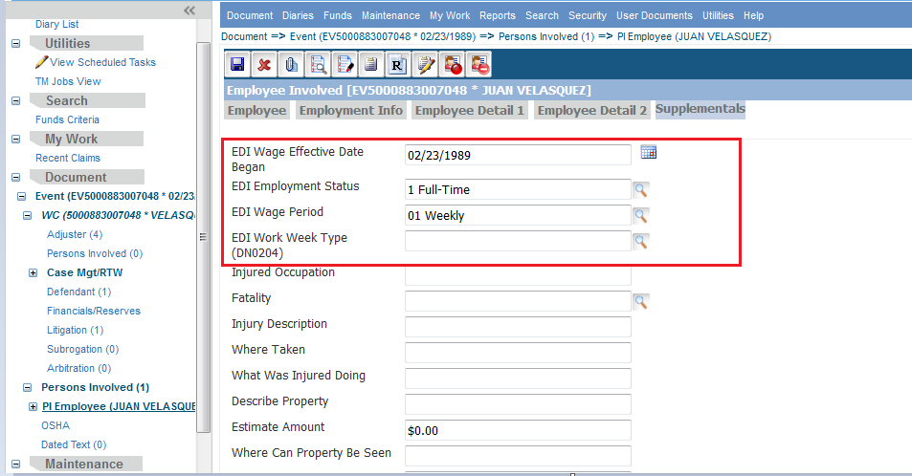

**1.1.4 Employee Supplemental Fields**  
For populating data into employee supplemental, use the following fields:  
  
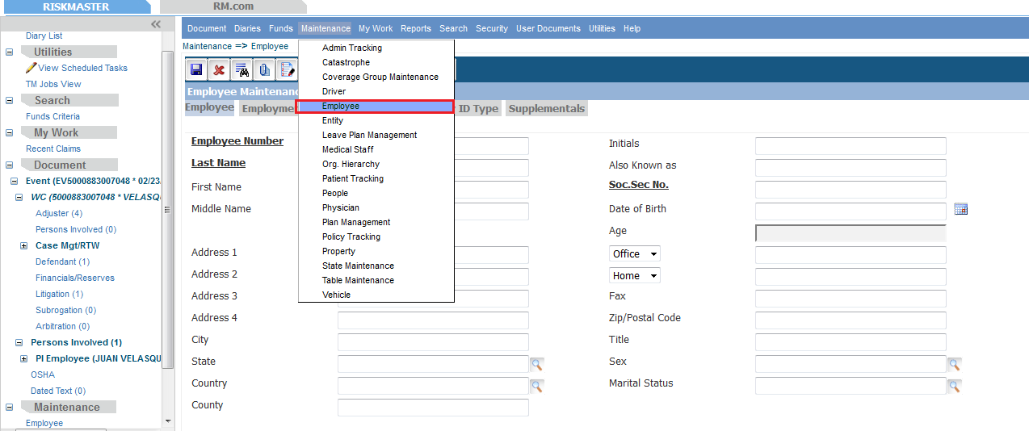  
  
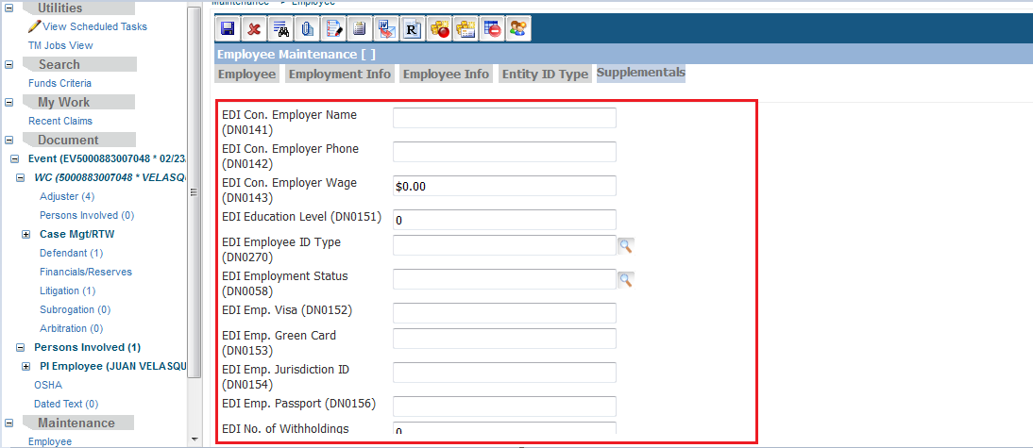  
  
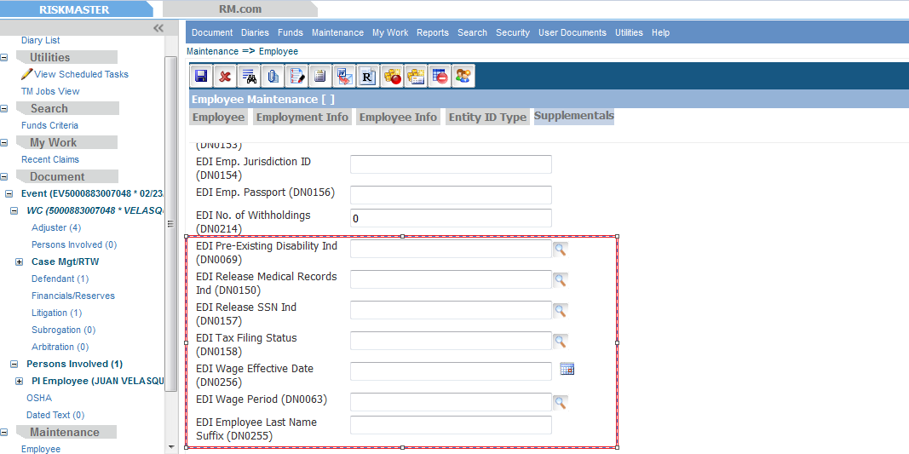

### **1.1.5 Entity Supplemental Fields**

For populating data into entity supplemental, use the following fields: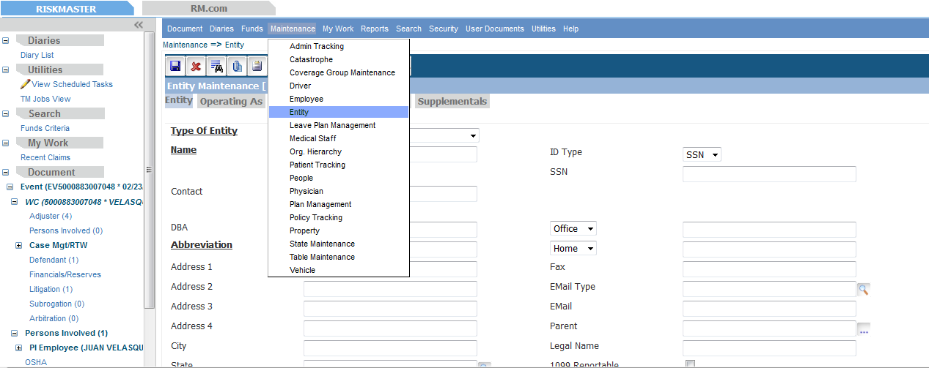  
  
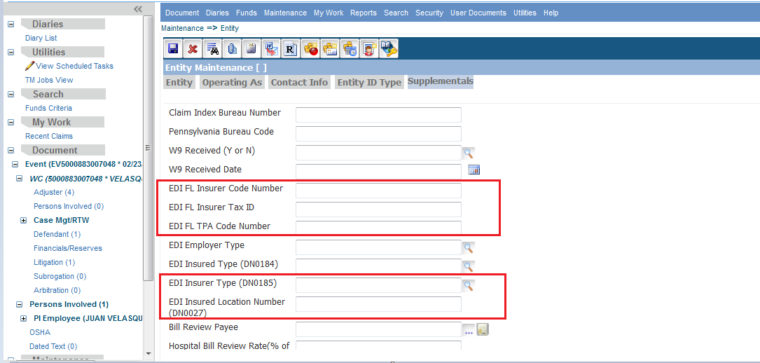  
  
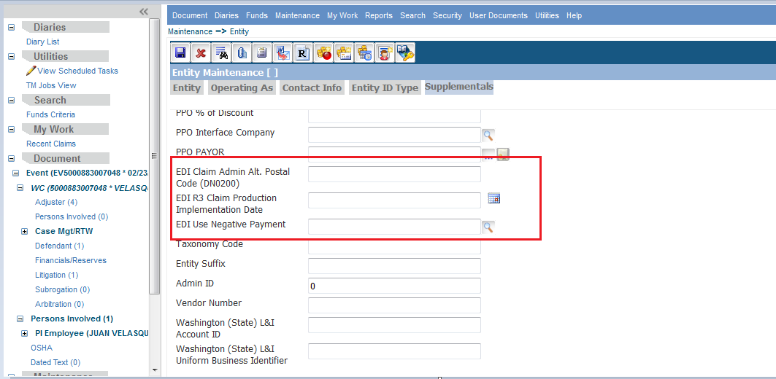

# **2.0 Medical EDI (Electronic Data Interchange) Screens**

We need to schedule the Medical EDI (Electronic data interchange) job from Riskmaster Accelerator Task manager screens. We can reach out to Medical EDI screen by clicking on the “Medical Extract” as shown below:

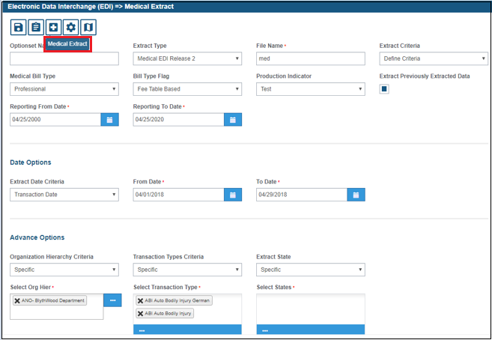

### **2.0.1 Trading Partners Screen**

We can reach out to this screen by clicking on the “Initial Configuration” tab of EDI.

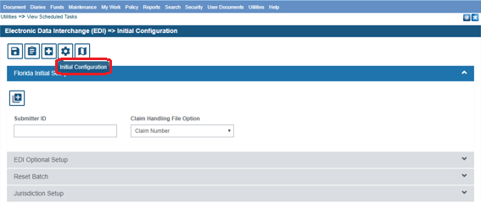

Select the EDI Initial Setup option as shown above.

**Note:** Trading Partner information is not required for the Florida Medical Bill EDI format. However, the Sender information is used in the Header record for the Florida Medical Bill reports.

The Trading Partner screen will be displayed after clicking “Jurisdiction Setup” as shown below:

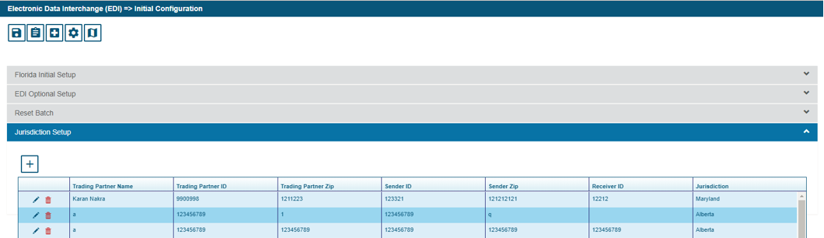

A Trading Partner table was added to the database and the data entered on the “Trading Partner for State” screen is now saved to the database. The Trading Partner information added into EDI should match the Trading Partner information in your Trading Partner Agreement exactly. This includes capitalization and full zip code. The Sender information added into EDI should match the Sender information in your Trading Partner Agreement exactly.

Follow the steps below to Add, Edit or Delete Trading Partners.

### 2.0.1.1 Add Trading Partner Information

Click on the “Add” button to update the data corresponding to the Trading Partners.

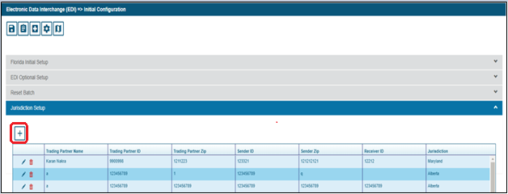

1. Select the “Add” button within the Trading Partner Information section of the screen. This will display the “Trading Partner for State” screen.
2. Select the Jurisdiction and enter data for all fields on the screen. The Report Type field does not need to be populated.
3. Select the “Save” button to save the data to the database or the “Cancel” button to close the screen without saving the data to the database.

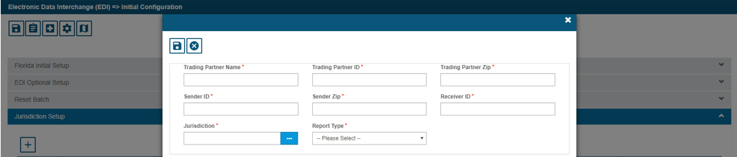

### 2.0.1.2 Edit Trading Partner Information

Select the Edit button as shown in the below tab to open the Trading Partner screen.

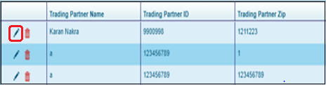

1) Select a Trading Partner from the list of Trading Partners.

2) Select the “Edit” button within the Trading Partner Information section of the screen. This will display the “Trading Partner for State” screen.   
3) Edit the fields on the screen that need to be updated.   
4) Select the “Save” button to save the data to the database or the “Cancel” button to close the screen without saving the data to the database.

### 2.0.1.3 Delete Trading Partner Information

Select the Delete button to delete the data corresponding to the specific trading Partner shown below:

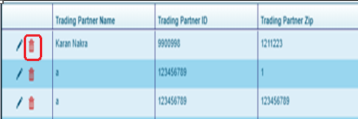

1) Select a Trading Partner from the list of Trading Partners.

2) Select the “Delete” button within the Trading Partner Information section of the screen. The Trading Partner is deleted from the list of Trading Partners and from the database.

### 2.0.2 EDI Optional Initial Setup

User can check this option to set the specific details.

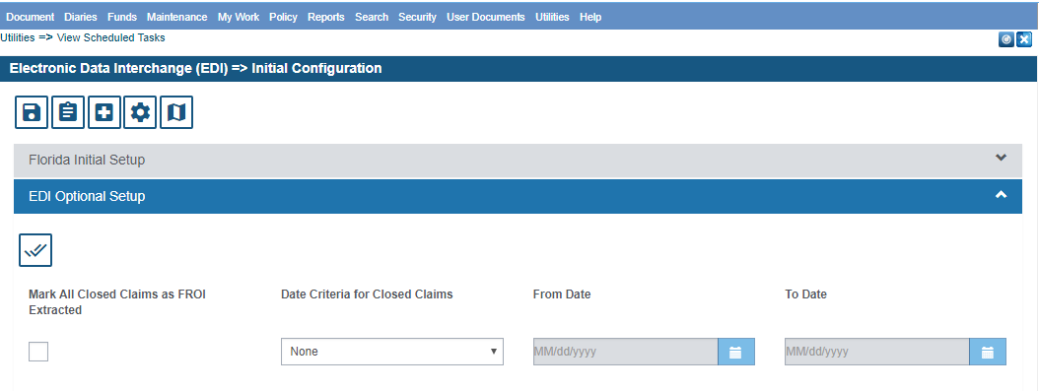

**Option: “What date criteria do you mark open or closed claims as FROI extracted?**

**Use this option to mark existing claim records as already reported to the state. You can mark claim records as being extracted by either date criteria or claim status.**

### 2.0.3 Florida Initial Setup

Set the Florida Medical EDI preferences using the below screen:

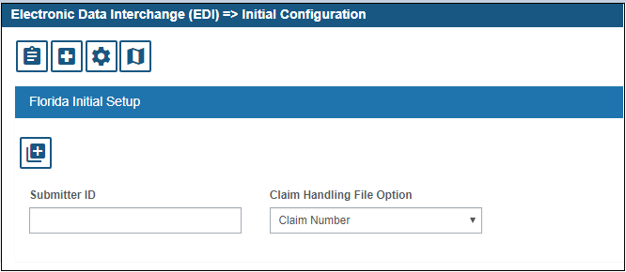

**Use “Submitter ID” text box to populate data corresponding to submitter information.  
  
Use “Claim Handling File Option” to specify the preferences for export via claim number or funds control number.**

### 2.0.4 Medical EDI Export Process

To schedule the job for Medical EDI export, user needs to select Medical Edi Release 2.0 option.

After the selection of Medical EDI Release 2.0, the below window will appear for the process.

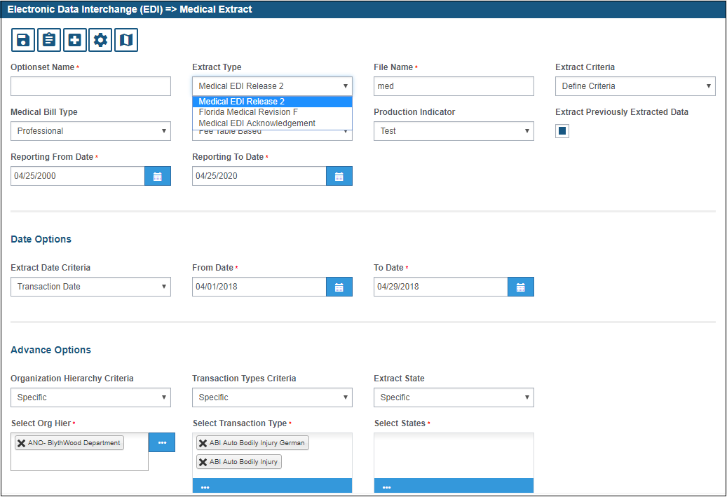

### 2.0.4.1 Define Criteria Option

The Medical EDI IAIABC Release 2.0 interface wizard will walk you through the process of extracting payments information from RISKMASTER. The screen is shown below:

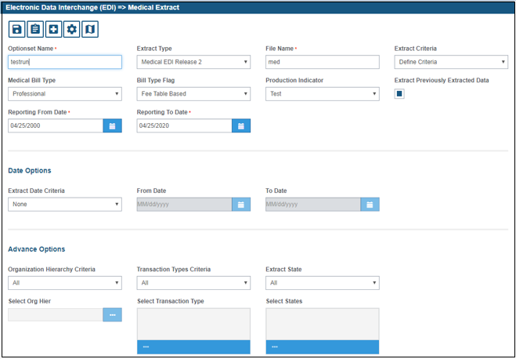

* The field “**Option Set Name”** is required to be given at the time of scheduling the job for Medical EDI Release 2.0. This name should be unique and can contain an alpha-numeric value.
* Select this option **Medical Bill Type** to choose which type of medical bill one want to extract.
* This option “**Bill Type Flag**” is used to select the criteria for which the data is required to be extracted. It may be of “Fee Table based” Or “BRS Bill Type based”.
* The “**Extract Previously Extracted Data**” option is used to extract data for the same payment if:
* The payment failed jurisdictional edits and the file was rejected by the state
* A second EDI Medical filing must be made for the same payment (Medical Release 2.0 filing with a different MTC code)
* An extract file was created but never set to the jurisdiction
* The “**Production Indicator**” option is used to populate the Test/Production Indicator field in the extract file. The field is a required field for all Medical EDI 2.0 filings

You may limit the claims extracted by the organizational hierarchy, applying date, claim type and state criteria. All departments under the selection will be included in the extract.

* Use the “All” option to extract claims regardless of what the department involved on the claim is set to. Use the “Specific” option to extract claims with a specific department involved.
* To select specific hierarchy levels, select the “Specific” option and click on the browse button. This will display the Organizational Hierarchy screen. Select a hierarchy level. This will add the selected hierarchy level to the list on the Medical EDI screen.

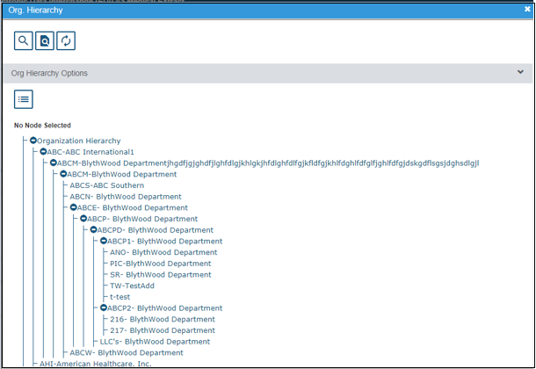

The “Specify payment” option allows the user to manually type in the control numbers that need to be extracted. This option should only be used if there are only a few payments to extract.

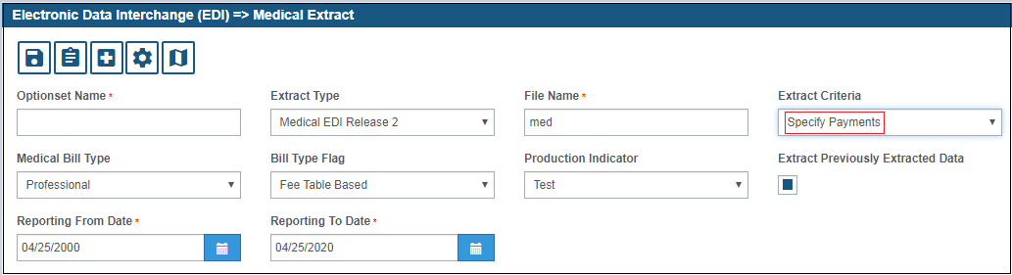

Upon initial entry into this screen, a list of control numbers that meet the defined criteria will display as shown below:

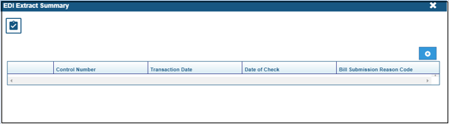

This step also allows you to enter additional control numbers of the payments you wish to extract which are not present in the list. When you have entered in the additional control numbers, choose the finish button to start the extract.

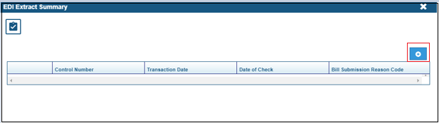

* To add additional payments to extract, type the control number in the field at the top of the screen and click the “Add” button. The control number will be added to the list of payments on the screen.
* If the entered control number is not existing in the Riskmaster database, then the exception will be thrown on the screen as shown below. Different exceptions will be displayed by putting up the wrong Control numbers on the screen.

### 2.0.4.3 Medical EDI Logs Screen

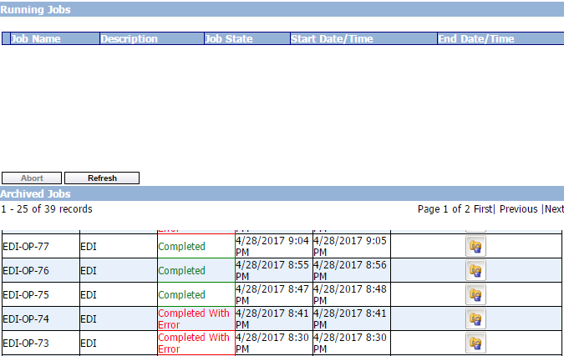

After the Job, will be executed, the Status of the jobs will be updated at the below screen as displayed.

To check the logs, click on the “Job Files zip file option” and the generated logs will be displayed.

### 2.0.4.4 Medical EDI Error Log

The error log file will be generated with the name as “errorlog.csv”, has been displayed below.

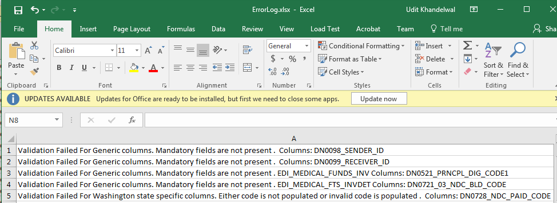

### 2.0.4.5 Medical EDI Process Log

The Process log will display the count of “Number of Extracted Claims” and “Number of claims not extracted” along with the Validation messages.

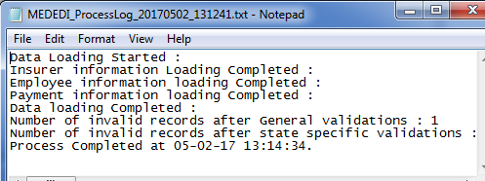

### 2.0.4.6 Medical EDI Export File Log

The EDI export file will be generated as per the IAIABC standards. The screenshot is shown below:

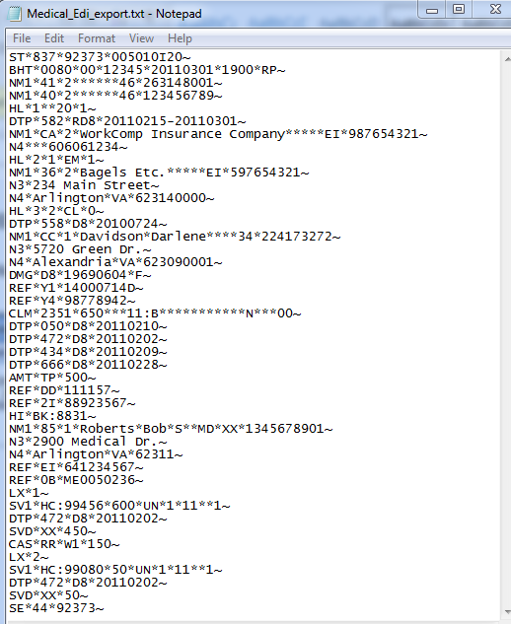

### 2.0.5 Medical EDI Import Process

This is used to import the Acknowledgement Report back into the RISKMASTER database. Select the update option and further select the “Riskmaster WC Claims” option to progress with the Import functionality.

The Update RISKMASTER WC Payments, this option is used to import Medical Acknowledgement Report data into RISKMASTER.

User needs to browse the Acknowledgement file by giving the unique “option set” name to start the process.

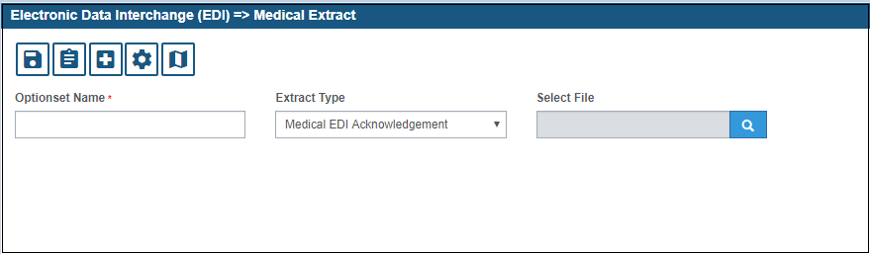

# **3.0 MEDICAL EDI FIELD MAPPING**

## **3.0.1 Export**

|  |  |  |  |  |
| --- | --- | --- | --- | --- |
| **DN #** | **Field Name** | **Required (YES (Y), NO(N))** | **Riskmaster Table. Field Name** | **Riskmaster Screen** |
| 532 | ORIGINATOR TRANSACTION IDENTIFICATION NUMBER | Y | Batch number for transaction and will be populated in EDI_MED_HISTORY |  |
| 100 | DATE TRANSMISSION SENT | Y |  | system date |
| 101 | TIME TRANSMISSION SENT | Y |  | system time |
| 98 | SENDER ID | Y | TRADING_PARTNER.SENDER_ID | Medical EDI Optionset Screen |
| 99 | RECEIVER ID | Y | TRADING_PARTNER.RECEIVER ID | Medical EDI Optionset Screen |
| 615 | REPORTING PERIOD | Y |  | Medical EDI Optionset Screen |
| 7 | INSURER NAME | Y | ENTITY.LAST_NAME | Entity/Org Hierarchy Maintenance Screen |
| 6 | INSURER FEIN | Y | ENTITY.TAX_ID | Entity/Org Hierarchy Maintenance Screen |
| 616 | INSURER POSTAL CODE | Y | ENTITY.ZIP_CODE | Entity/Org Hierarchy Maintenance Screen |
| 188 | CLAIM ADMINISTRATOR NAME | Y* | ENTITY.LAST_NAME | Entity Maintenance or Organization Hierarchy |
| 187 | CLAIM ADMINISTRATOR FEIN | Y* | ENTITY.TAX_ID | Entity Maintenance or Organization Hierarchy |
| 14 | CLAIM ADMINISTRATOR MAILING POSTAL CODE | Y* | ENTITY.ZIP_CODE | Entity Maintenance or Organization Hierarchy |
| 18 | EMPLOYER NAME | Y | ENTITY.LAST_NAME | Org Hierarchy Maintenance |
| 16 | EMPLOYER FEIN | N | ENTITY.TAX_ID | Org Hierarchy Maintenance |
| 31 | DATE OF INJURY | Y | EVENT.DATE_OF_EVENT | Event Screen |
| 43 | EMPLOYEE LAST NAME | Y | ENTITY.LAST_NAME | Entity Screen |
| 44 | EMPLOYEE FIRST NAME | Y | ENTITY.FIRST_NAME | Entity Screen |
| 45 | EMPLOYEE MIDDLE NAME/INITIAL | N | ENTITY.MIDDLE_NAME | Entity Screen |
| 255 | EMPLOYEE LAST NAME SUFFIX | N | ENTITY.SUFFIX_COMMON | Entity Screen |
| 42 | EMPLOYEE SSN | N | ENTITY.TAX_ID | Entity Screen |
| 153 | EMPLOYEE GREEN CARD | N | EMP_SUPP.GREEN_CARD | Employee Supplementals |
| 154 | EMPLOYEE ID ASSIGNED BY JURISDICTION | N | EMP_SUPP.JUR_ID | Employee Supplementals |
| 156 | EMPLOYEE PASSPORT NUMBER | N | EMP_SUPP.PASSPORT | Employee Supplementals |
| 152 | EMPLOYEE EMPLOYMENT VISA | N | EMP_SUPP.EMP_VISA | Employee Supplementals |
| 46 | EMPLOYEE MAILING PRIMARY ADDRESS | N | ENTITY.ADDR1 | Entity Screen |
| 47 | EMPLOYEE MAILING SECONDARY ADDRESS | N | ENTITY.ADDR2 | Entity Screen |
| 48 | EMPLOYEE MAILING CITY | N | ENTITY.CITY | Entity Screen |
| 49 | EMPLOYEE MAILING STATE CODE | N | ENTITY.STATE_ID | Entity Screen |
| 50 | EMPLOYEE MAILING POSTAL CODE | N | ENTITY.ZIP_CODE | Entity Screen |
| 155 | EMPLOYEE MAILING COUNTRY CODE | N | ENTITY.COUNTRY_CODE. Code table COUNTRY. | Entity Screen |
| 52 | EMPLOYEE DATE OF BIRTH | N | ENTITY.BIRTH_DATE | Entity Screen |
| 53 | EMPLOYEE GENDER CODE | N | ENTITY.SEX_CODE. Code Table SEX_CODE | Entity Screen |
| 15 | CLAIM ADMINISTRATOR CLAIM NUMBER | Y | CLAIM.CLAIM_NUMBER | Claim Screen |
| 5 | JURISDICTION CLAIM NUMBER | Y* | CLAIM_SUPP.AGNCY_CL_NUM/CLAIM.FILE_NUMBER | Claim Supplementals/Claim Screen |
| 51 | EMPLOYEE PHONE NUMBER | N | ENTITY.PHONE1 | Entity Screen |
| 523 | BILLING PROVIDER UNIQUE BILL IDENTIFICATION NUMBER | Y | FUNDS_TRANS_SPLIT.INVOICE_NUMBER | Transaction Screen |
| 501 | TOTAL CHARGE PER BILL | Y | INVOICE_DETAIL.AMOUNT_BILLED | BRS Screen |
| 502 | BILLING TYPE CODE | Y | INVOICE_DETAIL.BILL_TYPE. Code Table BILLTYPE | BRS Screen |
| 504 | FACILITY CODE | Y | INVOICE_DETAIL.PLACE_OF_SER_CODE. Code table PLACE_OF_SERVICE | BRS Screen |
| 555 | PLACE OF SERVICE BILL CODE | Y | INVOICE_DETAIL.PLACE_OF_SER_CODE. Code table PLACE_OF_SERVICE | BRS Screen |
| 503 | BILLING FORMAT CODE | Y | FUNDS_SUPP.BILLING_FORMAT_CODE. Code Table BILLING_FORMAT_CODE | Transaction Supplementals |
| 505 | BILL FREQUENCY TYPE CODE | Y | Hardcoded Value = 1 |  |
| 507 | PROVIDER AGREEMENT CODE | Y | FUNDS_SUPP.PROV_AGRMNT_CODE. Code Table PROV_AGRMNT_CODE | Transaction Supplementals |
| 508 | BILL SUBMISSION REASON CODE | Y | FUNDS_SUPP.BILL_SUB_RSN_CODE. Code table name BILL_SUB_RSN_CODE | Transaction Supplementals |
| 511 | DATE INSURER RECEIVED BILL | Y | FUNDS_SUPP.FL_RCVD_BILL | Transaction Supplementals |
| 513 | ADMISSION DATE | N | PATIENT.DATE_OF_ADMISSION | Patient Tracking - Admission Info |
| 622 | ADMISSION HOUR | N | PATIENT.TIME_OF_ADMISSION | Patient Tracking - Admission Info |
| 514 | DISCHARGE DATE | N | PATIENT.DATE_OF_DISCHARGE | Patient Tracking - Admission Info |
| 623 | DISCHARGE HOUR | N | PATIENT.TIME_OF_DISCHARGE | Patient Tracking - Admission Info |
| 509 | SERVICE BILL DATE(S) RANGE | Y | FUNDS_TRANS_SPLIT.TO_DATE | Transaction Details Screen |
| 527 | PRESCRIPTION DATE(S) RANGE | Y | INVOICE_DETAIL.PRESCRIP_DATE | BRS Screen |
| 510 | DATE OF BILL | Y | FUNDS.TRANS_DATE | Transaction Details Screen |
| 512 | DATE INSURER PAID BILL | Y | FUNDS.CHECK_DATE | Transaction Details Screen |
| 577 | ADMISSION TYPE CODE | Y | PATIENT.ADM_TYPE_CODE. Code Table ADMISSION_TYPE | Patient Tracking - Admission Info |
| 515 | CONTRACT TYPE CODE | N | FUNDS_SUPP.CONTRACT_TYPE_CODE. Code Table CONTRACT_TYPE_CODE | Transaction Supplementals |
| 516 | TOTAL AMOUNT PAID PER BILL | Y | FUNDS.AMOUNT | Transaction Details |
| 500 | UNIQUE BILL ID NUMBER | Y | FUNDS.TRANS_ID | Transaction Details |
| 266 | TRANSACTION TRACKING NUMBER | Y | FUNDS.CTL_NUMBER | Transaction Details |
| 581 | TREATMENT AUTHORIZATION NUMBER | N | NA | NA |
| 293 | LUMP SUM PAYMENT/SETTLEMENT CODE | Y | CLAIM_SUPP.LUMP_SUM_PMT. Code Table LUMP_SUM_PMT | Claims Screen |
| 521 | PRINCIPAL DIAGNOSIS CODE | Y* | FUNDS_SUPP.FL_PRIN_ICD_DIAG | Transaction Supplementals |
| 533 | PRESENT ON ADMISSION INDICATOR | N | NA | NA |
| 535 | ADMITTING DIAGNOSIS CODE | Y* | FUNDS_SUPP.ADMTNG_DIAG_CODE | Transaction Supplementals |
| 522 | DIAGNOSIS CODE | N | INVDETAIL_X_DIAG_ICD10.DIAGNOSIS_CODE/INVDETAIL_X_DIAG.DIAGNOSIS_CODE | BRS Screen |
| 533 | PRESENT ON ADMISSION INDICATOR | N | NA | ATL Will Handle |
| 522 | DIAGNOSIS CODE | N | INVDETAIL_X_DIAG_ICD10.DIAGNOSIS_CODE/INVDETAIL_X_DIAG.DIAGNOSIS_CODE | BRS Screen |
| 533 | PRESENT ON ADMISSION INDICATOR | N | NA |  |
| 522 | DIAGNOSIS CODE | N | INVDETAIL_X_DIAG_ICD10.DIAGNOSIS_CODE/INVDETAIL_X_DIAG.DIAGNOSIS_CODE | BRS Screen |
| 533 | PRESENT ON ADMISSION INDICATOR | N | NA |  |
| 522 | DIAGNOSIS CODE | N | INVDETAIL_X_DIAG_ICD10.DIAGNOSIS_CODE/INVDETAIL_X_DIAG.DIAGNOSIS_CODE | BRS Screen |
| 533 | PRESENT ON ADMISSION INDICATOR | N | NA |  |
| 522 | DIAGNOSIS CODE | N | INVDETAIL_X_DIAG_ICD10.DIAGNOSIS_CODE/INVDETAIL_X_DIAG.DIAGNOSIS_CODE | BRS Screen |
| 533 | PRESENT ON ADMISSION INDICATOR | N | NA |  |
| 522 | DIAGNOSIS CODE | N | INVDETAIL_X_DIAG_ICD10.DIAGNOSIS_CODE/INVDETAIL_X_DIAG.DIAGNOSIS_CODE | BRS Screen |
| 533 | PRESENT ON ADMISSION INDICATOR | N | NA |  |
| 522 | DIAGNOSIS CODE | N | INVDETAIL_X_DIAG_ICD10.DIAGNOSIS_CODE/INVDETAIL_X_DIAG.DIAGNOSIS_CODE | BRS Screen |
| 533 | PRESENT ON ADMISSION INDICATOR | N | NA |  |
| 522 | DIAGNOSIS CODE | N | INVDETAIL_X_DIAG_ICD10.DIAGNOSIS_CODE/INVDETAIL_X_DIAG.DIAGNOSIS_CODE | BRS Screen |
| 533 | PRESENT ON ADMISSION INDICATOR | N | NA |  |
| 522 | DIAGNOSIS CODE | N | INVDETAIL_X_DIAG_ICD10.DIAGNOSIS_CODE/INVDETAIL_X_DIAG.DIAGNOSIS_CODE | BRS Screen |
| 533 | PRESENT ON ADMISSION INDICATOR | N | NA |  |
| 522 | DIAGNOSIS CODE | N | INVDETAIL_X_DIAG_ICD10.DIAGNOSIS_CODE/INVDETAIL_X_DIAG.DIAGNOSIS_CODE | BRS Screen |
| 533 | PRESENT ON ADMISSION INDICATOR | N | NA |  |
| 522 | DIAGNOSIS CODE | N | INVDETAIL_X_DIAG_ICD10.DIAGNOSIS_CODE/INVDETAIL_X_DIAG.DIAGNOSIS_CODE | BRS Screen |
| 533 | PRESENT ON ADMISSION INDICATOR | N | NA |  |
| 522 | DIAGNOSIS CODE | N | INVDETAIL_X_DIAG_ICD10.DIAGNOSIS_CODE/INVDETAIL_X_DIAG.DIAGNOSIS_CODE | BRS Screen |
| 533 | PRESENT ON ADMISSION INDICATOR | N | NA |  |
| 520 | OUTPATIENT REASON FOR VISIT CODE | N | FUNDS_SUPP.MED EDI OUTPATIENT REASON FOR VISIT CODE | Transaction Supplementals |
| 520 | OUTPATIENT REASON FOR VISIT CODE | N | NA |  |
| 520 | OUTPATIENT REASON FOR VISIT CODE | N | NA |  |
| 521 | PRINCIPAL DIAGNOSIS CODE | Y | FUNDS_SUPP.FL_PRIN_ICD_DIAG | Transaction Supplementals |
| 522 | DIAGNOSIS CODE | N | INVDETAIL_X_DIAG_ICD10.DIAGNOSIS_CODE/INVDETAIL_X_DIAG.DIAGNOSIS_CODE | BRS Screen |
| 522 | DIAGNOSIS CODE | N | INVDETAIL_X_DIAG_ICD10.DIAGNOSIS_CODE/INVDETAIL_X_DIAG.DIAGNOSIS_CODE | BRS Screen |
| 522 | DIAGNOSIS CODE | N | INVDETAIL_X_DIAG_ICD10.DIAGNOSIS_CODE/INVDETAIL_X_DIAG.DIAGNOSIS_CODE | BRS Screen |
| 522 | DIAGNOSIS CODE | N | INVDETAIL_X_DIAG_ICD10.DIAGNOSIS_CODE/INVDETAIL_X_DIAG.DIAGNOSIS_CODE | BRS Screen |
| 522 | DIAGNOSIS CODE | N | INVDETAIL_X_DIAG_ICD10.DIAGNOSIS_CODE/INVDETAIL_X_DIAG.DIAGNOSIS_CODE | BRS Screen |
| 522 | DIAGNOSIS CODE | N | INVDETAIL_X_DIAG_ICD10.DIAGNOSIS_CODE/INVDETAIL_X_DIAG.DIAGNOSIS_CODE | BRS Screen |
| 522 | DIAGNOSIS CODE | N | INVDETAIL_X_DIAG_ICD10.DIAGNOSIS_CODE/INVDETAIL_X_DIAG.DIAGNOSIS_CODE | BRS Screen |
| 522 | DIAGNOSIS CODE | N | INVDETAIL_X_DIAG_ICD10.DIAGNOSIS_CODE/INVDETAIL_X_DIAG.DIAGNOSIS_CODE | BRS Screen |
| 522 | DIAGNOSIS CODE | N | INVDETAIL_X_DIAG_ICD10.DIAGNOSIS_CODE/INVDETAIL_X_DIAG.DIAGNOSIS_CODE | BRS Screen |
| 522 | DIAGNOSIS CODE | N | INVDETAIL_X_DIAG_ICD10.DIAGNOSIS_CODE/INVDETAIL_X_DIAG.DIAGNOSIS_CODE | BRS Screen |
| 522 | DIAGNOSIS CODE | N | INVDETAIL_X_DIAG_ICD10.DIAGNOSIS_CODE/INVDETAIL_X_DIAG.DIAGNOSIS_CODE | BRS Screen |
| 525 | PRINCIPAL PROCEDURE CODE | N | FUNDS_SUPP.FL_PRIN_PROC | Transaction Supplementals |
| 550 | PRINCIPAL PROCEDURE DATE | Y* | FUNDS_SUPP.PRNCPL_PROC_DATE | Transaction Supplementals |
| 736 | OTHER PROCEDURE CODE | N | NA |  |
| 524 | PROCEDURE DATE | Y* | PI_X_PROCEDURE.DATE_OF_PROCEDURE | Patient Tracking Screen- Add employee as PI |
| 736 | OTHER PROCEDURE CODE | N | NA |  |
| 524 | PROCEDURE DATE | Y* | PI_X_PROCEDURE.DATE_OF_PROCEDURE |  |
| 736 | OTHER PROCEDURE CODE | N | NA |  |
| 524 | PROCEDURE DATE | Y* | PI_X_PROCEDURE.DATE_OF_PROCEDURE |  |
| 736 | OTHER PROCEDURE CODE | N | NA |  |
| 524 | PROCEDURE DATE | Y* | PI_X_PROCEDURE.DATE_OF_PROCEDURE |  |
| 736 | OTHER PROCEDURE CODE | N | NA |  |
| 524 | PROCEDURE DATE | Y* | PI_X_PROCEDURE.DATE_OF_PROCEDURE |  |
| 736 | OTHER PROCEDURE CODE | N | NA |  |
| 524 | PROCEDURE DATE | Y* | PI_X_PROCEDURE.DATE_OF_PROCEDURE |  |
| 736 | OTHER PROCEDURE CODE | N | NA |  |
| 524 | PROCEDURE DATE | Y* | PI_X_PROCEDURE.DATE_OF_PROCEDURE |  |
| 736 | OTHER PROCEDURE CODE | N | NA |  |
| 524 | PROCEDURE DATE | Y* | PI_X_PROCEDURE.DATE_OF_PROCEDURE |  |
| 736 | OTHER PROCEDURE CODE | N | NA |  |
| 524 | PROCEDURE DATE | Y* | PI_X_PROCEDURE.DATE_OF_PROCEDURE |  |
| 736 | OTHER PROCEDURE CODE | N | NA |  |
| 524 | PROCEDURE DATE | Y* | PI_X_PROCEDURE.DATE_OF_PROCEDURE |  |
| 736 | OTHER PROCEDURE CODE | N | NA |  |
| 524 | PROCEDURE DATE | Y* | PI_X_PROCEDURE.DATE_OF_PROCEDURE |  |
| 736 | OTHER PROCEDURE CODE | N | NA |  |
| 524 | PROCEDURE DATE | Y* | PI_X_PROCEDURE.DATE_OF_PROCEDURE |  |
| 556 | CONDITION CODE | N | NA | NA |
| 556 | CONDITION CODE | N | NA | NA |
| 556 | CONDITION CODE | N | NA | NA |
| 556 | CONDITION CODE | N | NA | NA |
| 556 | CONDITION CODE | N | NA | NA |
| 556 | CONDITION CODE | N | NA | NA |
| 556 | CONDITION CODE | N | NA | NA |
| 556 | CONDITION CODE | N | NA | NA |
| 556 | CONDITION CODE | N | NA | NA |
| 556 | CONDITION CODE | N | NA | NA |
| 556 | CONDITION CODE | N | NA | NA |
| 556 | CONDITION CODE | N | NA | NA |
| 549 | PAID DRG CODE | N | NA |  |
| 548 | BILLED DRG CODE | N | NA |  |
| 528 | BILLING PROVIDER LAST/GROUP NAME | Y | ENTITY.LAST_NAME | Entity Maintenance screen( Payee information) |
| 529 | BILLING PROVIDER FIRST NAME | N | ENTITY.FIRST_NAME | Entity Maintenance screen( Payee information) |
| 530 | BILLING PROVIDER MIDDLE NAME/INITIAL | N | ENTITY.MIDDLE_NAME | Entity Maintenance screen( Payee information) |
| 531 | BILLING PROVIDER LAST NAME SUFFIX | N | ENTITY.SUFFIX_COMMON | Entity Maintenance screen( Payee information) |
| 634 | BILLING PROVIDER NATIONAL PROVIDER ID | N | ENTITY.NPI_NUMBER | Entity Maintenance screen( Payee information) |
| 537 | BILLING PROVIDER PRIMARY SPECIALTY CODE | N | NA |  |
| 538 | BILLING PROVIDER PRIMARY ADDRESS | Y | ENTITY.ADDR1 | Entity Maintenance screen( Payee information) |
| 539 | BILLING PROVIDER SECONDARY ADDRESS | N | ENTITY.ADDR2 | Entity Maintenance screen( Payee information) |
| 540 | BILLING PROVIDER CITY | Y | ENTITY.CITY | Entity Maintenance screen( Payee information) |
| 541 | BILLING PROVIDER STATE CODE | N | ENTITY.STATE_ID | Entity Maintenance screen( Payee information) |
| 542 | BILLING PROVIDER POSTAL CODE | N | ENTITY.ZIP_CODE | Entity Maintenance screen( Payee information) |
| 569 | BILLING PROVIDER COUNTRY CODE | N | ENTITY.COUNTRY_CODE | Entity Maintenance screen( Payee information) |
| 629 | BILLING PROVIDER FEIN | Y | ENTITY.TAX_ID | Entity Maintenance screen( Payee information) |
| 630 | BILLING PROVIDER STATE LICENSE NUMBER | N | NA |  |
| 638 | RENDERING BILL PROVIDER LAST/GROUP NAME | N | NA |  |
| 639 | RENDERING BILL PROVIDER FIRST NAME | N | NA |  |
| 640 | RENDERING BILL PROVIDER MIDDLE NAME/INITIAL | N | NA |  |
| 641 | RENDERING BILL PROVIDER LAST NAME SUFFIX | N | NA |  |
| 647 | RENDERING BILL PROVIDER NATIONAL PROVIDER ID | N | NA |  |
| 651 | RENDERING BILL PROVIDER PRIMARY SPECIALTY CODE | N | NA |  |
| 642 | RENDERING BILL PROVIDER FEIN | N | NA |  |
| 643 | RENDERING BILL PROVIDER STATE LICENSE NUMBER | N | NA |  |
|  | SUPERVISING PROVIDER LAST/GROUP NAME | N | FUNDS_SUPP.SUPERVISOR_EID | Transaction Supplemental |
| 659 | SUPERVISING PROVIDER FIRST NAME | N | FUNDS_SUPP.SUPERVISOR_EID | Transaction Supplemental |
| 660 | SUPERVISING PROVIDER MIDDLE NAME/INITIAL | N | FUNDS_SUPP.SUPERVISOR_EID | Transaction Supplemental |
| 661 | SUPERVISING PROVIDER LAST NAME SUFFIX | N | FUNDS_SUPP.SUPERVISOR_EID | Transaction Supplemental |
| 667 | SUPERVISING PROVIDER NATIONAL PROVIDER ID | N | FUNDS_SUPP.SUPERVISOR_EID | Transaction Supplemental |
| 671 | SUPERVISING PROVIDER PRIMARY SPECIALTY CODE | N | FUNDS_SUPP.SUPERVISOR_EID | Transaction Supplemental |
| 663 | SUPERVISING PROVIDER STATE LICENSE NUMBER | N | FUNDS_SUPP.SUPERVISOR_EID | Transaction Supplemental |
|  | FACILITY NAME | N | INVOICE.LAST_NAME_TEXT | Transaction Screen |
| 682 | FACILITY NATIONAL PROVIDER ID | N | FUNDS_SUPP.FL_FAC_NPI_TEXT | Transaction Supplemental |
| 684 | FACILITY PRIMARY ADDRESS | Y* | INVOICE.ADDR1_TEXT | Transaction Screen |
| 685 | FACILITY SECONDARY ADDRESS | N | INVOICE.ADDR2_TEXT | Transaction Screen |
| 686 | FACILITY CITY | Y* | INVOICE.CITY | Transaction Screen |
| 687 | FACILITY STATE CODE | N | INVOICE.STATE_ID | Transaction Screen |
| 688 | FACILITY POSTAL CODE | N | INVOICE.POSTAL_CODE_TEXT | Transaction Screen |
| 689 | FACILITY COUNTRY CODE | N | INVOICE.COUNTRY_CODE | Transaction Screen |
| 680 | FACILITY STATE LICENSE NUMBER | N | NA |  |
|  | FACILITY SERVICE LOCATION ID | N | NA |  |
| 690 | REFERRING PROVIDER LAST/GROUP NAME | N | ENTITY.LAST_NAME | BRS Screen (physician information) |
| 691 | REFERRING PROVIDER FIRST NAME | N | ENTITY.FIRST_NAME |  |
| 692 | REFERRING PROVIDER MIDDLE NAME/INITIAL | N | ENTITY.MIDDLE_NAME |  |
| 693 | REFERRING PROVIDER LAST NAME SUFFIX | N | ENTITY.SUFFIX_COMMON |  |
| 699 | REFERRING PROVIDER NATIONAL PROVIDER ID | N | ENTITY.NPI_NUMBER |  |
| 695 | REFERRING PROVIDER STATE LICENSE NUMBER | N | ENTITY.WC_FILING_NUMBER |  |
| 209 | MANAGED CARE ORGANIZATION NAME | N | ENTITY.LAST_NAME | Claim screen |
| 208 | MANAGED CARE ORGANIZATION IDENTIFICATION NUMBER | N | ENTITY.TAX_ID |  |
| 704 | MANAGED CARE ORGANIZATION FEIN | N | NA |  |
| 543 | BILL ADJUSTMENT GROUP CODE | N | NA |  |
| 544 | BILL ADJUSTMENT REASON CODE | N | NA |  |
| 545 | BILL ADJUSTMENT AMOUNT | N | NA |  |
| 546 | BILL ADJUSTMENT UNITS | N | NA |  |
| 544 | BILL ADJUSTMENT REASON CODE | N | NA |  |
| 545 | BILL ADJUSTMENT AMOUNT | N | NA |  |
| 546 | BILL ADJUSTMENT UNITS | N | NA |  |
| 544 | BILL ADJUSTMENT REASON CODE | N | NA |  |
| 545 | BILL ADJUSTMENT AMOUNT | N | NA |  |
| 546 | BILL ADJUSTMENT UNITS | N | NA |  |
| 760 | PRIOR ACTUAL AMOUNT PAID | N | NA |  |
| 547 | LINE NUMBER |  |  | ATL generate |
| 714 | HCPCS LINE PROCEDURE BILLED CODE | N | FUNDS_SUPP.JURIS_PROC_BLD_CODE | Transaction Supplemental |
| 715 | JURISDICTION PROCEDURE BILLED CODE | N | FUNDS_SUPP.JURIS_PROC_BLD_CODE | Transaction Supplemental |
| 721 | NDC BILLED CODE | N | INVOICE_DETAIL.PHY_PHARM_NDC | BRS Screen |
| 717 | HCPCS MODIFIER BILLED CODE | N | NA |  |
| 718 | JURISDICTION MODIFIER BILLED CODE | N | NA |  |
| 717 | JURISDICTION MODIFIER BILLED CODE | N | NA |  |
| 717 | HCPCS MODIFIER BILLED CODE | N | NA |  |
| 717 | JURISDICTION MODIFIER BILLED CODE | N | NA |  |
| 717 | HCPCS MODIFIER BILLED CODE | N | NA |  |
| 717 | JURISDICTION MODIFIER BILLED CODE | N | NA |  |
| 551 | PROCEDURE DESCRIPTION | N | PI_X_PROCEDURE.PROCEDURE_CODE | Patient Tracking Screen- Add employee as PI |
| 552 | TOTAL CHARGE PER LINE | Y | INVOICE_DETAIL.AMOUNT | BRS Screen |
| 553 | DAYS(S)/UNIT(S) CODE | Y | INVOICE_DETAIL.UNITS_BILLED_TYPE | BRS Screen |
| 554 | DAY(S) /UNIT(S) BILLED | Y | INVOICE_DETAIL.UNITS_BILLED_NUM | BRS Screen |
| 600 | PLACE OF SERVICE LINE CODE | N | INVOICE_DETAIL.PLACE_OF_SER_CODE | BRS Screen |
| 557 | DIAGNOSIS POINTER | Y | INVOICE_DETAIL.DIAG_REF_NO | BRS Screen |
| 557 | DIAGNOSIS POINTER | N | NA |  |
| 557 | DIAGNOSIS POINTER | N | NA |  |
| 557 | DIAGNOSIS POINTER | N | NA |  |
| 742 | PROVIDER AGREEMENT LINE CODE | N | NA |  |
| 559 | REVENUE BILLED CODE | Y | INVOICE_DETAIL.REV_CODE | BRS Screen |
| 714 | HCPCS LINE PROCEDURE BILLED CODE | N | FUNDS_SUPP.JURIS_PROC_BLD_CODE | Transaction Supplemental |
| 625 | HIPPS RATE CODE | N | NA |  |
| 715 | JURISDICTION PROCEDURE BILLED CODE | N | FUNDS_SUPP.JURIS_PROC_BLD_CODE | Transaction Supplemental |
| 717 | HCPCS MODIFIER BILLED CODE | N | NA |  |
| 718 | JURISDICTION MODIFIER BILLED CODE | N | NA |  |
| 717 | HCPCS MODIFIER BILLED CODE | N | NA |  |
| 718 | JURISDICTION MODIFIER BILLED CODE | N | NA |  |
| 717 | HCPCS MODIFIER BILLED CODE | N | NA |  |
| 718 | JURISDICTION MODIFIER BILLED CODE | N | NA |  |
| 717 | HCPCS MODIFIER BILLED CODE | N | NA |  |
| 718 | JURISDICTION MODIFIER BILLED CODE | N | NA |  |
| 551 | PROCEDURE DESCRIPTION | N | NA |  |
| 552 | TOTAL CHARGE PER LINE | Y | INVOICE_DETAIL.AMOUNT | BRS Screen |
| 553 | DAYS(S)/UNIT(S) CODE | Y | INVOICE_DETAIL.UNITS_BILLED_TYPE | BRS Screen |
| 554 | DAY(S) /UNIT(S) BILLED | Y | INVOICE_DETAIL.UNITS_BILLED_NUM | BRS Screen |
| 719 | ADA PROCEDURE BILLED CODE | N | FUNDS_SUPP.JURIS_PROC_BLD_CODE | Transaction Supplemental |
| 714 | HCPCS LINE PROCEDURE BILLED CODE | N | FUNDS_SUPP.JURIS_PROC_BLD_CODE | Transaction Supplemental |
| 717 | HCPCS MODIFIER BILLED CODE | N | NA |  |
| 717 | HCPCS MODIFIER BILLED CODE | N | NA |  |
| 717 | HCPCS MODIFIER BILLED CODE | N | NA |  |
| 717 | HCPCS MODIFIER BILLED CODE | N | NA |  |
| 551 | PROCEDURE DESCRIPTION | N | NA |  |
| 552 | TOTAL CHARGE PER LINE | Y | INVOICE_DETAIL.AMOUNT | BRS Screen |
| 600 | PLACE OF SERVICE LINE CODE | N | INVOICE_DETAIL.PLACE_OF_SER_CODE | BRS Screen |
| 742 | PROVIDER AGREEMENT LINE CODE | N | NA | FUNDS_TRANS_SPLIT (Code field) |
| 557 | DIAGNOSIS POINTER | Y | INVOICE_DETAIL.DIAG_REF_NO | BRS Screen |
| 557 | DIAGNOSIS POINTER | N | NA |  |
| 557 | DIAGNOSIS POINTER | N | NA |  |
| 557 | DIAGNOSIS POINTER | N | NA |  |
| 561 | PRESCRIPTION LINE NUMBER | Y | INVOICE_DETAIL.PRESCRIP_NO | BRS Screen |
| 721 | NDC BILLED CODE | Y | INVOICE_DETAIL.PHY_PHARM_NDC | BRS Screen |
| 562 | DISPENSE AS WRITTEN CODE | Y | INVOICE_DETAIL.DISPENSED. Code Table DISPENSE_WRITTEN_CODE | BRS Screen |
| 563 | DRUG NAME | N | INVOICE_DETAIL.DRUG_NAME | BRS Screen |
| 762 | COMPOUND DRUG INDICATOR | N | hardcoded Value in ATL as 'N' |  |
| 605 | SERVICE LINE DATE(S) RANGE | Y | FUNDS_TRANS_SPLIT.FROM_DATE AND FUNDS_TRANS_SPLIT.TO_DATE | Transaction Screen |
| 604 | PRESCRIPTION LINE DATE | Y | INVOICE_DETAIL.PRESCRIP_DATE | BRS Screen |
| 570 | DRUGS/SUPPLIES QUANTITY DISPENSED | Y | INVOICE_DETAIL.MEDS_QUANTITY | BRS Screen |
| 571 | DRUGS/SUPPLIES NUMBER OF DAYS | Y | INVOICE_DETAIL.DAYS_SUPPLIED | BRS Screen |
| 741 | CONTRACT LINE TYPE CODE | N | NA |  |
| 738 | TREATMENT LINE AUTHORIZATION NUMBER | N | NA |  |
| 579 | DRUGS/SUPPLIES DISPENSING FEE | N | INVOICE_DETAIL.RX_USUAL_CHARGE | BRS Screen |
| 572 | DRUGS/SUPPLIES BILLED AMOUNT | Y | INVOICE_DETAIL.AMOUNT_BILLED | BRS Screen |
| 627 | LINE ITEM TAX CHARGE AMOUNT | N | NA |  |
| 721 | NDC BILLED CODE | N | NA |  |
| 721 | NDC BILLED CODE | Y* | INVOICE_DETAIL.PHY_PHARM_NDC | BRS Screen |
| 553 | DAYS(S)/UNIT(S) CODE | N | NA |  |
| 561 | PRESCRIPTION LINE NUMBER | Y* | INVOICE_DETAIL.PRESCRIP_NO | BRS Screen |
| 589 | RENDERING LINE PROVIDER LAST/GROUP NAME | N | NA |  |
| 587 | RENDERING LINE PROVIDER FIRST NAME | N | NA |  |
| 591 | RENDERING LINE PROVIDER MIDDLE NAME/INITIAL | N | NA |  |
| 588 | RENDERING LINE PROVIDER LAST NAME SUFFIX | N | NA |  |
| 592 | RENDERING LINE PROVIDER NATIONAL PROVIDER ID | N | NA |  |
| 595 | RENDERING LINE PROVIDER PRIMARY SPECIALTY CODE | N | NA |  |
| 586 | RENDERING LINE PROVIDER FEIN | N | NA |  |
| 599 | RENDERING LINE PROVIDER STATE LICENSE NUMBER | N | NA |  |
| 574 | TOTAL AMOUNT PAID PER LINE | Y* | INVOICE_DETAIL.AMOUNT_TO_PAY | BRS Screen |
| 722 | ADA PROCEDURE PAID CODE | N | FUNDS_SUPP.JURIS_PROC_PD_CODE | Transaction Supplemental |
| 726 | HCPCS LINE PROCEDURE PAID CODE | N | FUNDS_SUPP.JURIS_PROC_PD_CODE | Transaction Supplemental |
| 728 | NDC PAID CODE | N | FUNDS_SUPP.NDC_PAID_CODE | Transaction Supplemental |
| 729 | JURISDICTION PROCEDURE PAID CODESVN | N | FUNDS_SUPP.JURIS_PROC_PD_CODE | Transaction Supplemental |
| 727 | HCPCS MODIFIER PAID CODE | N | NA |  |
| 730 | JURISDICTION MODIFIER PAID CODE | N | NA |  |
| 727 | HCPCS MODIFIER PAID CODE | N | NA |  |
| 730 | JURISDICTION MODIFIER PAID CODE | N | NA |  |
| 727 | HCPCS MODIFIER PAID CODE | N | NA |  |
| 730 | JURISDICTION MODIFIER PAID CODE | N | NA |  |
| 727 | HCPCS MODIFIER PAID CODE | N | NA |  |
| 730 | JURISDICTION MODIFIER PAID CODE | N | NA |  |
| 576 | REVENUE PAID CODE | N | NA |  |
| 580 | DAYS(S)/UNIT(S) PAID | N | NA |  |
| 547 | LINE NUMBER |  | NA |  |
| 731 | SERVICE ADJUSTMENT GROUP CODE | Y* |  | HARDCODE in ATL |
| 732 | SERVICE ADJUSTMENT REASON CODE | Y* | INVOICEDETAIL_X_EOB | BRS Screen |
| 733 | SERVICE ADJUSTMENT AMOUNT | Y* | INVOICE_DETAIL.AMOUNT_REDUCED | BRS Screen |
| 734 | SERVICE ADJUSTMENT UNITS | N | NA |  |
| 732 | SERVICE ADJUSTMENT REASON CODE | Y* | INVOICEDETAIL_X_EOB | BRS Screen |
| 733 | SERVICE ADJUSTMENT AMOUNT | Y* | INVOICEDETAIL_X_EOB | BRS Screen |
| 734 | SERVICE ADJUSTMENT UNITS | N | NA |  |
| 732 | SERVICE ADJUSTMENT REASON CODE | Y* | INVOICEDETAIL_X_EOB | BRS Screen |
| 733 | SERVICE ADJUSTMENT AMOUNT | Y* | INVOICEDETAIL_X_EOB | BRS Screen |
| 734 | SERVICE ADJUSTMENT UNITS | N | NA |  |
| 732 | SERVICE ADJUSTMENT REASON CODE | Y* | INVOICEDETAIL_X_EOB | BRS Screen |
| 733 | SERVICE ADJUSTMENT AMOUNT | Y* | INVOICEDETAIL_X_EOB | BRS Screen |
| 734 | SERVICE ADJUSTMENT UNITS | N | NA |  |
| 732 | SERVICE ADJUSTMENT REASON CODE | Y* | INVOICEDETAIL_X_EOB | BRS Screen |
| 733 | SERVICE ADJUSTMENT AMOUNT | Y* | INVOICEDETAIL_X_EOB | BRS Screen |
| 734 | SERVICE ADJUSTMENT UNITS | N | NA |  |
| 761 | LINE ITEM PRIOR ACTUAL AMOUNT PAID | N | NA |  |
| 628 | LINE ITEM TAX PAID AMOUNT | N | NA |  |

## **3.0.2 Import**

|  |  |  |
| --- | --- | --- |
| **Segment #** | **Field Name** | **Riskmaster Table. Field Name** |
| ST01 | TRANSACTION SET IDENTIFIER CODE | EDI_MED_HISTORY.TRANS_SET_ID_CODE_ST |
| ST02 | TRANSACTION SET CONTROL NUMBER | EDI_MED_HISTORY.TRANS_SET_CTL_NUM_ST |
| ST03 | IMPLEMENTATION CONVENTION REFERENCE | EDI_MED_HISTORY.IMPLEMENT_CONVENTION_REF_ST |
| BGN01 | TRANSACTION SET PURPOSE CODE | EDI_MED_HISTORY.TRANS_SET_PURPOSE_CODE_BGN |
| BGN02 | REFERENCE IDENTIFICATION | EDI_MED_HISTORY.REF_IDENTIFICATION_BGN |
| BGN03 | DATE | EDI_MED_HISTORY.DATE_BGN |
| BGN04 | TIME | EDI_MED_HISTORY.TIME_BGN |
| BGN08 | ACTION CODE | EDI_MED_HISTORY.ACTION_CODE_BGN |
| N104 | IDENTIFICATION CODE(Sender) | EDI_MED_HISTORY.SUBMITTER_ID |
| N104 | IDENTIFICATION CODE(Receiver) | EDI_MED_HISTORY.RECEIVER_ID |
| OTI01 | APPLICATION ACKNOWLEDGMENT CODE | EDI_MED_HISTORY.APP_ACK_CODE_OTI |
| OTI02 | REFERENCE IDENTIFICATION QUALIFIER | EDI_MED_HISTORY.REF_ID_QUALIFIER_OTI |
| OTI03 | REFERENCE IDENTIFICATION | EDI_MED_HISTORY.REF_IDENTIFICATION_OTI |
| OTI06 | DATE | EDI_MED_HISTORY.DATE_OTI |
| OTI07 | TIME | EDI_MED_HISTORY.TIME_OTI |
| OTI10 | TRANSACTION SET IDENTIFIER CODE | EDI_MED_HISTORY.TRANS_SET_ID_CODE_OTI |
| REF01 | REFERENCE IDENTIFICATION QUALIFIER | EDI_MED_HISTORY.REF_ID_QUALIFIER_REF |
| REF02 | REFERENCE IDENTIFICATION | EDI_MED_HISTORY.REF_IDENTIFICATION_REF |
| DTM01 | DATE/TIME QUALIFIER | EDI_MED_HISTORY.DTTM_QUALIFIER_DTM |
| DTM02 | DATE | EDI_MED_HISTORY.DATE_DTM |
| DTM03 | TIME | EDI_MED_HISTORY.TIME_DTM |
| LM01 | AGENCY QUALIFIER CODE | EDI_MED_HISTORY.AGNCY_QUALIFIER_CODE_LM |
| LQ01 | CODE LIST QUALIFIER CODE | EDI_MED_HISTORY.CODE_LST_QUALIFIER_CODE_LQ |
| LQ02 | INDUSTRY CODE | EDI_MED_HISTORY.IND_CODE_LQ |
| RED01 | DESCRIPTION | EDI_MED_HISTORY.DESCRIPTION_RED |
| RED03 | AGENCY QUALIFIER CODE | EDI_MED_HISTORY.AGNCY_QUALIFIER_CODE_RED |
| RED05 | CODE LIST QUALIFIER CODE | EDI_MED_HISTORY.CODE_LST_QUALIFIER_CODE_RED |
| RED06 | INDUSTRY CODE | EDI_MED_HISTORY.IND_CODE_RED |
| SE01 | NUMBER OF INCLUDED SEGMENTS | EDI_MED_HISTORY.NO_OF_INCLUDED_SEGMENTS_SE |
| SE02 | TRANSACTION SET CONTROL NUMBER | EDI_MED_HISTORY.TRANS_SET_CTL_NUM_SE |